**Period:** 2023

**Source:** <https://www.ncdc.noaa.gov/stormevents/>

**Event timing and identification:**

1. Events used for analysis in this project (flash flood, flood, coastal flood, storm surge/tide, and Lakeshore flood.) The graph below shows the counts of these events, with flash floods and floods amongst the most common types of natural disasters.

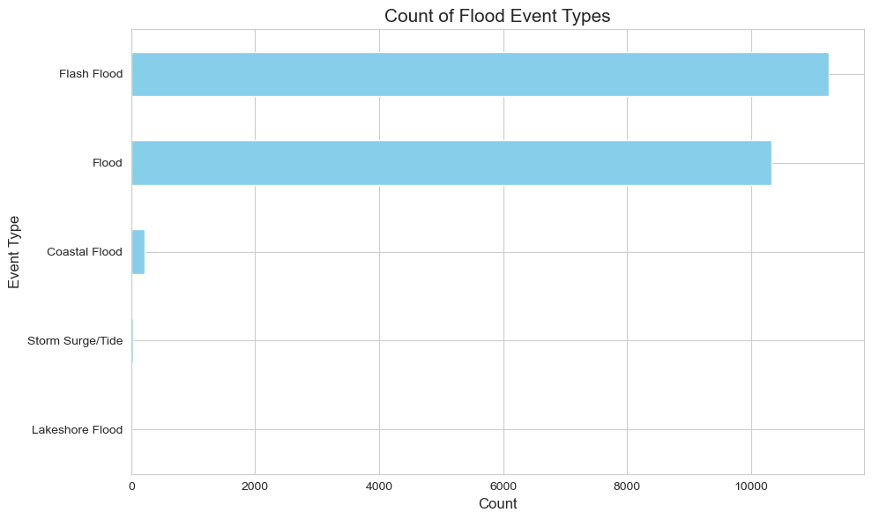

1. The Histogram of the duration of floods (right skewed histogram below implies that most of the floods have a shorter total duration (in hours), with certain outliers on the right that last longer. (max flood duration in our dataset ~ 744 hours)

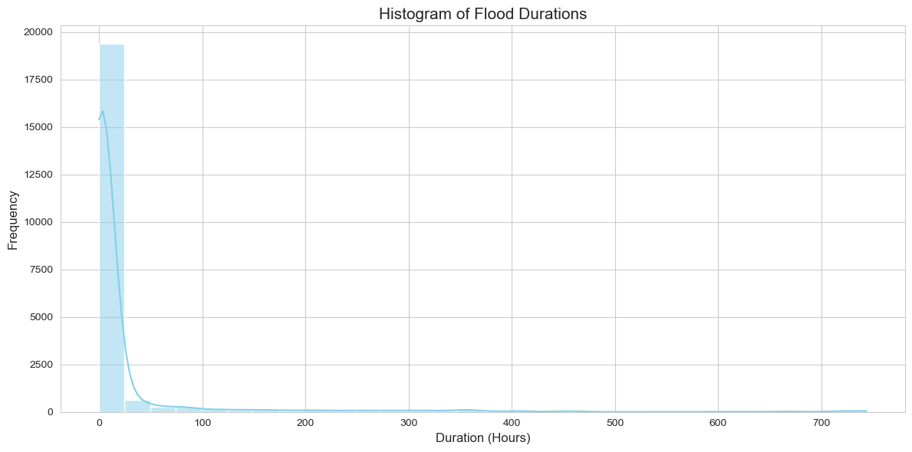

1. Distribution of floods by months with the size of dots indicating the duration of these floods (in hours.) Big dots indicate floods that lasted for a longer duration than average.

(interactive plot with filters available for months and duration)

<https://public.tableau.com/app/profile/shumail.sajjad/viz/DDSPFinalProject/Graph1>

File: 3.html (it shows the same thing differently with month as a filter only)

**Event Details:**

1. Another overview of the geographic regions with floods with more details/ statistics on each end pin.

File: 4.html

1. States with Property/Crop damage from Floods

File: 5.html

**Human Impact:**

1. States with Fatalities/ Injuries from Floods

File: 6.html

1. Distribution of fatalities by age

It shows the age brackets for fatalities from these floods. The majority of the people were > 50 years old.

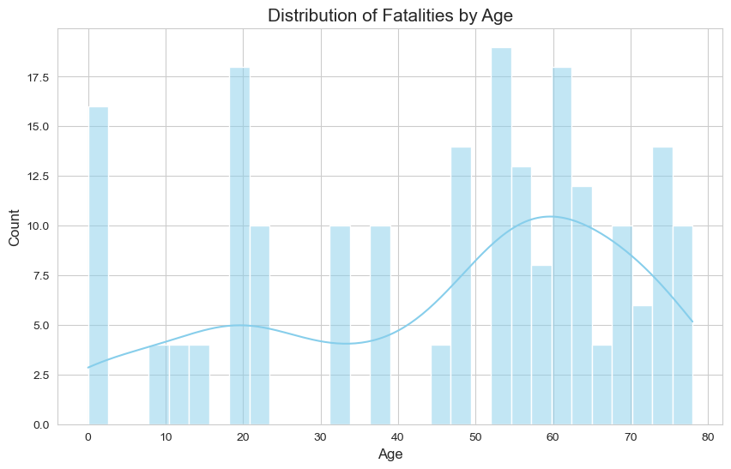

1. Fatalities by Gender

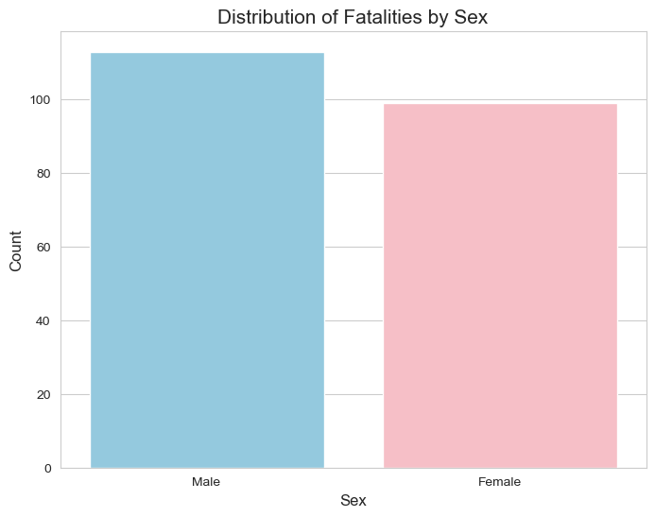

**Outlier states/ clusters in the data** (based on weighted attention to duration, deaths, property, and crop damage from these floods → model used was IsolationForest)

9.html + 10.html